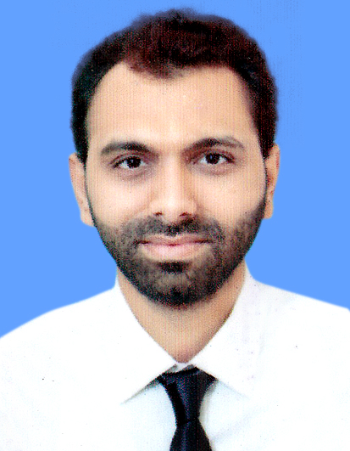  Contact  Address  B-19, Block13-c, Gulshan-E-Iqbal Karachi  Phone  0311-2025899  Email  shoaib_tahir1990@yahoo.com  Personal  Father’s Name  Tahir Muhammad  Date of Birth  July 06, 1990  CNIC No.  42000-8021285-9  Field of Interest  - Finance  - Accounting  Personal Statement  If you have a habit to learn, success is always in search of you… | SHOAIB TAHIR  OBJECTIVE:  To seek a career position in a progressive organization, offering a challenging job where I can exercise my abilities, learn new skills and education can be utilized.  WORK EXPERIENCE  SCHOLASTIC  SKILLS AND INTERESTS  - Internet Application and Browsing, Emailing.  - Diploma In Digital Media (Graphic Designing)  - Windows XP  - Ms Office (Excel, PowerPoint, Word)
  Duration | Organization | Designation | Jobs Task
  Aug 2019 – to June 2021 | IDL Distribution | Accountant | - Bill Issue  - Dealing with basic bookkeeping  - Account Receivable & Payable & Chq Entry on Excel  - Booking Sheet Entry on Software  - Accounts Ledger  - Filing Documents & Bills
  July 2018 – to June 2019 | The Educator School | Assistant  Accountant | - Maintain petty cash and expenses records Cash collection and Payment record & Cheque Requisition  - Dealing with basic bookkeeping  - Filing School Documents  - Maintain Bank reconciliation  - Print school vouchers and dealing with parents
  Jan 2017 – Aug 2017 | Trade Optimize | Accountant / Admin | - Maintain petty cash and expenses records Cash collection and Payment record & Ledger entry  - Dealing with basic bookkeeping  - Maintain Bank reconciliation, Balance sheet & Income Statement  - Drafts, formats, and prints relevant documents & Maintains stock lists and orders office supplies as needed
  Jan 2012 – Oct 2016 | Imperious | Accountant | - Cash collection and Payment record & Ledger entry  - Dealing with basic bookkeeping  - Maintain Bank reconciliation, Financial statement, Balance sheet & Income Statement
  Jan 2005 – Dec 2011 | Bhukhari Oil Mill | Accountant | - Maintain Cash collection and Payment record, Dealing with basic bookkeeping & Inventory recording
  Year | Institution | Qualification | Grade/CGPA
  2014 – 2017 | Iqra University | MBA (Finance) | 2.85 CGPA
  2009 – 2013 | Iqra University | BBA- H | 2.93 CGPA
  2008 – 2009 | Govt. National College | Intermediate  (Commerce) | B Grade
  2006 – 2007 | Oxford High School, Karachi | Matriculation (Science) | A Grade

